中國文化日—凱風中文學校附設多元文化研究中心主辦
中美珠心算學會
Chinese American Abacus Association
1363 Jacklin Road, Milpitas, CA 95035 Web Site:www.caaa-abacus.org Tel & Fax: (408) 263-7966 E-mail:caaa@usa.com
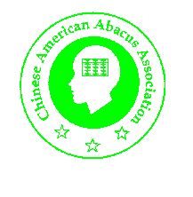
Castro Valley School District 協辦

Thursday, May 13, 2004
Jensen Ranch Elementary School
20001 Carson Lane, Castro Valley, CA 94552
Magic Abacus
神機妙算 (算盤 – 神奇的古老計算機)

Introduction to the Abacus:
A) Jenny Ma is a high school students. she will give a short presentation on history of the abacus.

B) A demonstration of Mental Math using abacus skills will be followed.
Performers are:
Roger Chen: 5th grade student
Joshua Huang: 5th grade student
Kevin Chen: 2nd grade student

They will be doing different level of arithmetic calculations.

Teacher : 黃惠姜 老師

Outdoor Hands on Project: Make your own abacus
Teacher : 樓玉蘭 老師

…

