“享與饗” 社區文化日—五月十五日
中美珠心算學會
Chinese American Abacus Association
1363 Jacklin Road, Milpitas, CA 95035 Web Site:www.caaa-abacus.org Tel & Fax: (408) 263-7966 E-mail:caaa@usa.com
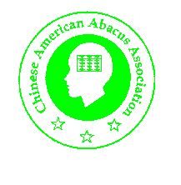
北加州中文學校聯合會與San Jose Berryessa School District 主辨:

Abacus Magic
2:10pm—2:18pm Suggestion Show Time
A) Two high school students will give a short presentation on history of the abacus.

Angela Hsueh –11th grade student
Jenny Ma -- 10th grade student
Instructors: Harry Ma

B) A demonstration of Mental Math using abacus skills will be followed.
Performers are

Kevin Zhang—6th grade student
Victor Chen— 6th grade student
Brain Shieh— 4th grade student
Jerry Sun ─ 3th grade student
Instructors: Shiew-Jy Hsieh
Huey Chiang Huang

Outdoor Hands on Project—1:00-5:00pm

Instructors: 方萃藍 老師
黃惠姜 老師
義工-- Mrs. Kailei Hsieh
義工-- Peylih Shih
義工-- Harry Ma

