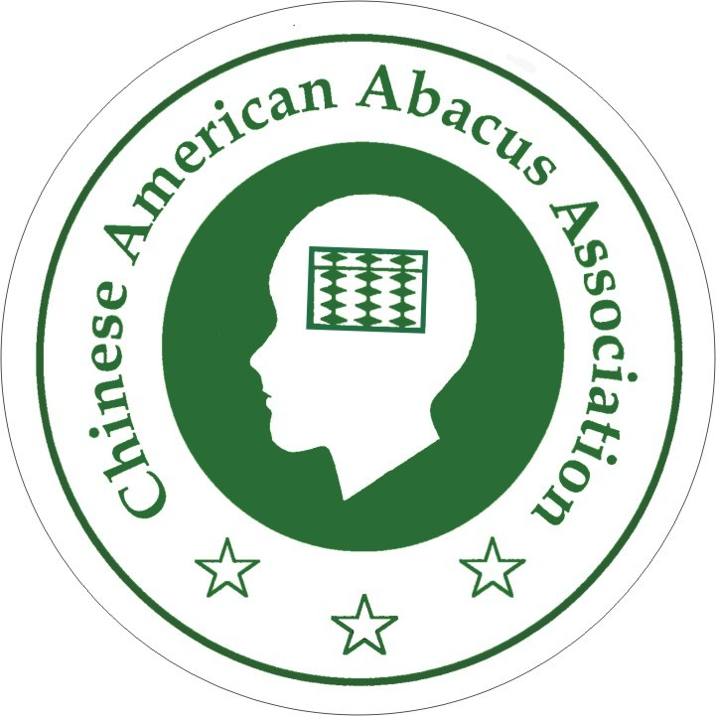
Chinese American Abacus Association
中美珠心算學會
1363 Jacklin Road
Milpitas, California 95035
Tel/Fax: (408) 263-7966
E-mail: caaa.us@gmail.com
www.caaa-abacus.org

PARTICIPATION = COMMUNITY SERVICE HOURS

EVENT: ________________________________________________

Name |  |  |  | Grade
Address
Telephone
e-mail
Experience
Date | Morning  8:00~12:00 | Afternoon  12:00~5:00 | Evening  6:30~8:30 |  | Please check that the time shift will fit your schedule.

Please e-mail your application form to caaa.us@gmail.com

